Predicting Collision Severity
- Introduction
1.1 The Background
The Seattle Traffic Department needs to reduce the number of road traffic accidents that occur on the city roads. Given the available data, it has been agreed that the best approach would be to be able to predict the severity of accidents that may occur due to certain conditions. It is believed that this new information will help with better planning and decision making for all stakeholders thereby reducing the risks and by extension, reducing the possibility of the occurrence of future accidents.

1.2 The Problem
Over time, the Traffic Department has established a correlation between several factors such as weather, traffic, etc and the severity of road traffic accidents. The extent of this correlation remains sketchy and this model intends to determine the extent of these dependencies and predict how they affect the severity of car accidents.

The expected audience of this report includes but is not restricted to the following:
- The Seattle Traffic Department
- Seattle Police Department
- Seattle Emergency Services
- The Medical Board/Hospitals
- All road users in Seattle
- Travellers that may drive to/through Seattle enroute other destinations.

2. Data
The dataset labelled Data_Collissions .csv is rich. It comprises of 37 attributes (columns) and 299 observations(rows) some of which will be used to test and train the Machine Learning Model. Supervised Machine Learning will be applied and as such the data must be labelled and balanced for a non-biased model. Some of the attributes have missing values, some attributes may not be useful and will be dropped. The severity attribute uses a non-binary classifier. Two or more machine learning models may be used to get the best results.
The data set spans years 2004 through to 2020 and contains information about collisions that occurred with this period.
2.1 Data Cleaning
The dataset had columns that had repetitive information while others contained insufficient information or missing values altogether.
Columns that had many missing values were dropped. Columns had inconsistencies with data types which would pose a problem in processing. These were also dropped. Missing numerical data were filled using the average while missing categorical data were filled with the mode.
2.2 Feature Selection
There were 194, 673 samples and 42 features after sorting.

3. Methodology
The target variable is already available as severity code. The correlation between other variables as analyzed.
3.1 Relationship between collision type and days of the week
It was observed that the 4th day of the week had the highest number of collisions with parked cars being the highest affected while the 6th day of the week had the overall lowest number of collisions.

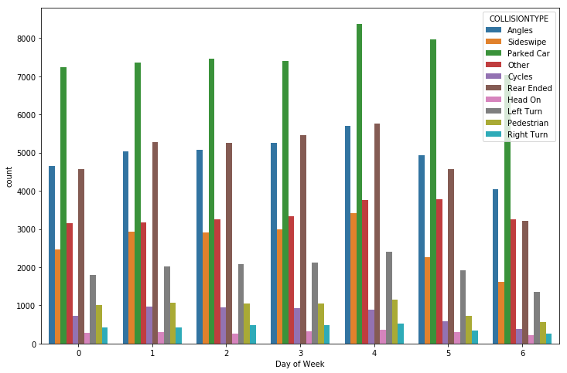
Fig 1.

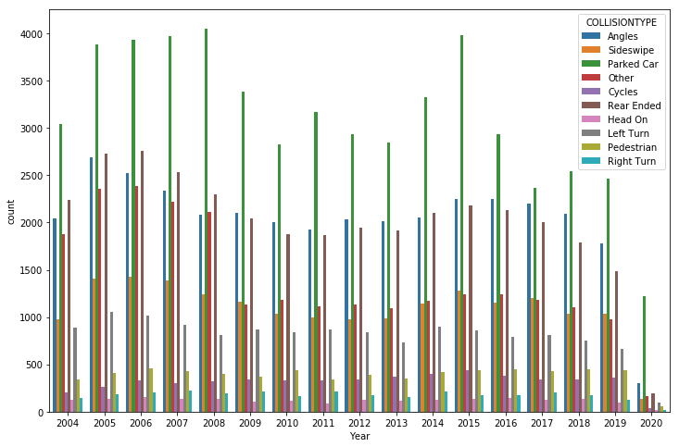
Fig2
The above figure shows the distribution of collision types over the period.

An analysis of the relationship between collision type and severity code showed that all collisions involving pedestrians, head-on, left turn and parked car resulted in higher type 2 severity, i.e a higher severity with injury and property damage. Cycle collisions have a lower severity, most only recording property damage.
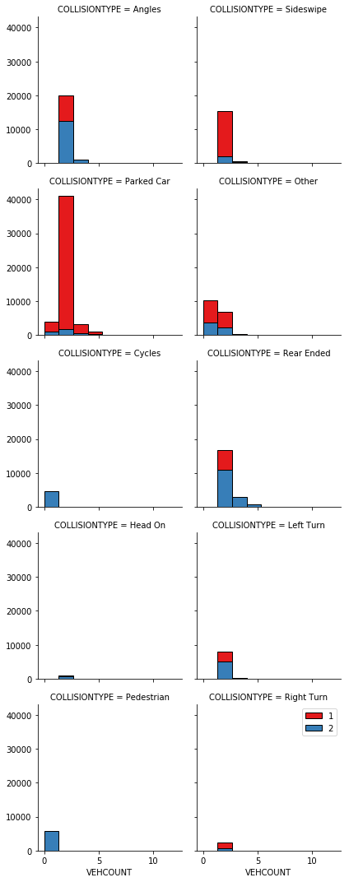

4. Results & Conclusion

Algorithm | Accuracy Score
KNN | 0.744
LR(Logistic Regression) | 0.749
DT(Decision Tree) | 0.745

Logistic Regression performed best. This model will be useful in predicting the severity of collisions by helping to identify the areas where the severe collisions occur, help redesign parking areas to reduce the occurrence of Type 1 severity collisions etc.
I believe that with better processing, training and testing, the model can be even more accurate.

